**COMP3021 Project 2: SS Chat Documentation**

Sungsu Lim (20020006)

**Description**

In this project, an online chatting room system is implemented based on Client - Server mode. We implement two sides, the Server part and the Client part. They are all implemented in user-friendly GUI that allows a convenient usage by the user. The Server-Side is responsible for managing all connected Clients and receiving/transmitting messages to and from Clients. The Client-Side allows the user to log-on to the system and chat with single or multiple users anonymously.

**System Overview**

A summary of the main functionalities are described below.

From the Main, where the initial logon screen is shown, the user can either access the Server-Side or the Client-Side GUI. New user registration hasn’t been fully implemented and the system only does a weak check on the credentials (it checks if the ID is “server” or “client”).

Server

Client

Main

The Server-Side and the Client-Side have the following functionalities as shown below:

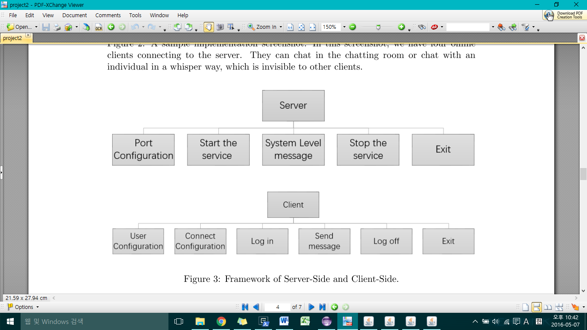

**Implementation**

* **Main (Login to Client/Server-Side):** Main GUI implements the Login functionality to allow access to Client/Server-Side.

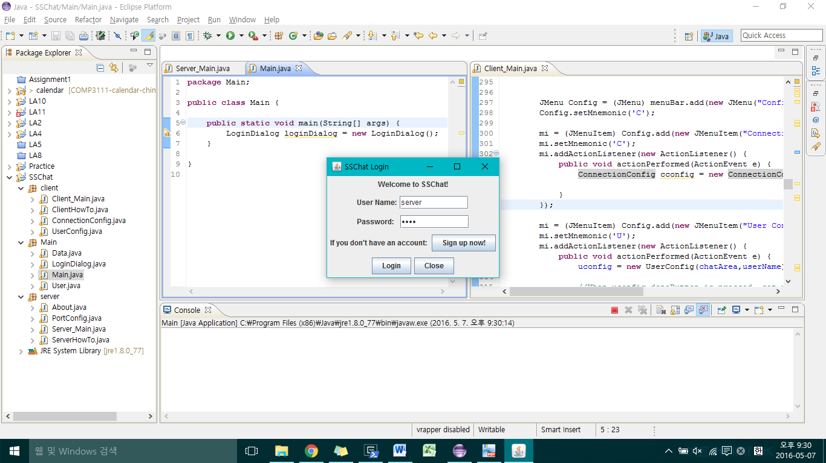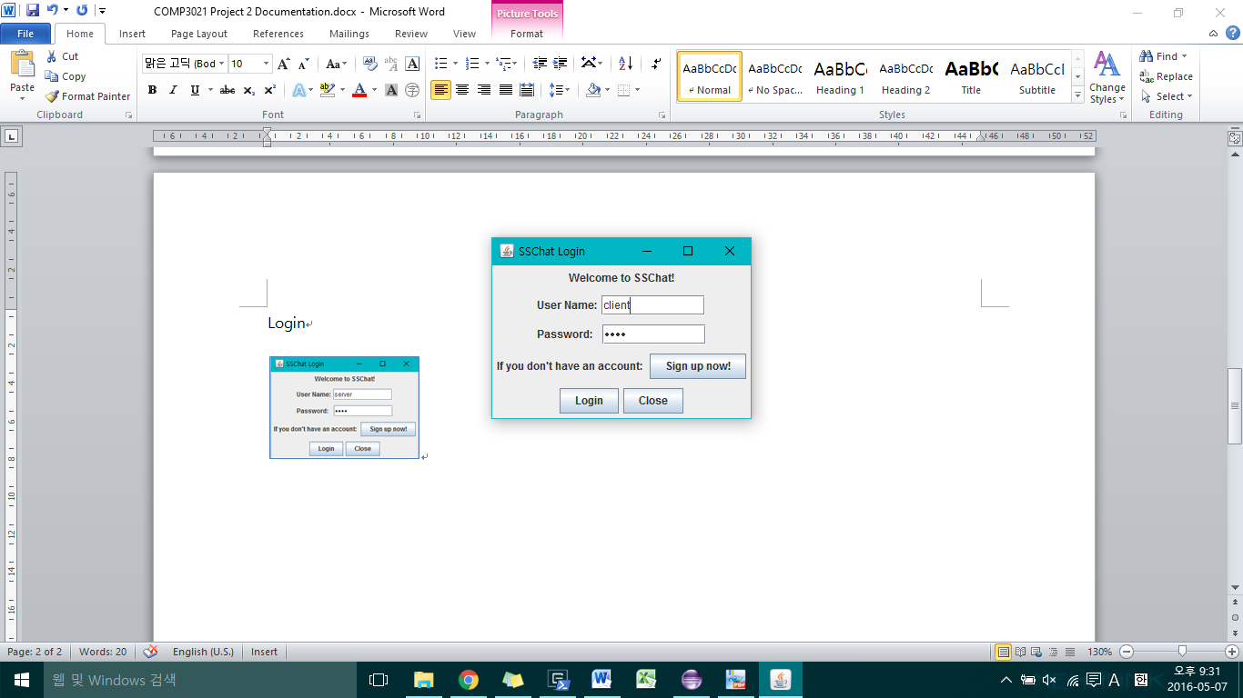

**Server-Side:**

* **Port Configuration**: Sets the listening port. The default port is 8888. The default port number is shown in the textfield when you open PortConfiguration. After editing, when you press Done Button, the Listener updates Port Number accordingly.

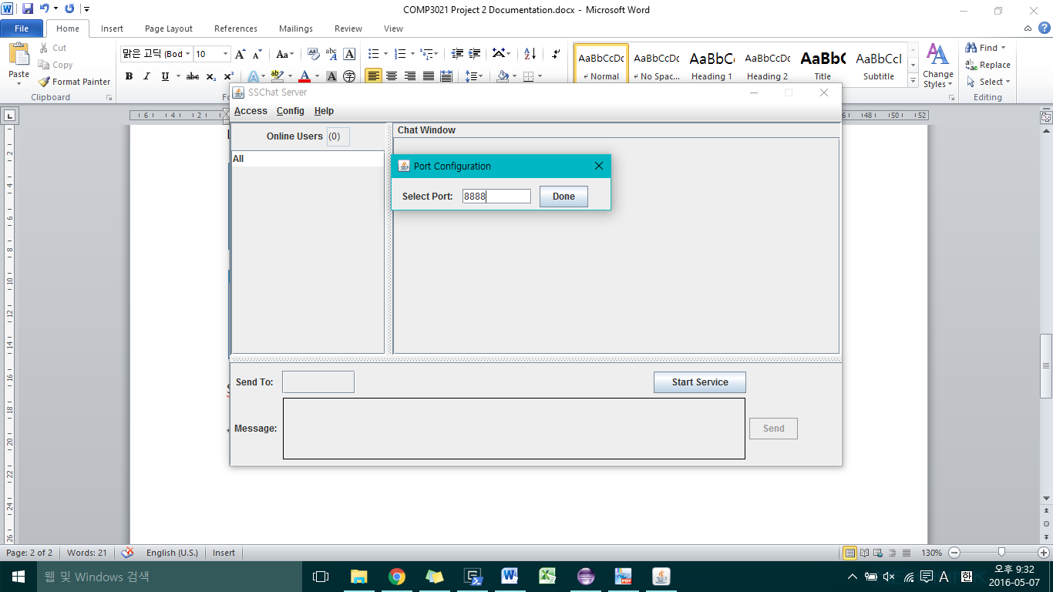

* **Start / End Service**: Starts/Ends the service and connects/disconnects Clients. When starting service, the Server implements a thread that listens for new Client connections. For every new Client connection, the Server creates a new thread that listens for input from that particular Client only. When ending service, whether by clicking the End Service Button, Exit, or due to unexpected error, the Server sends termination signal to all users online before closing the Server.

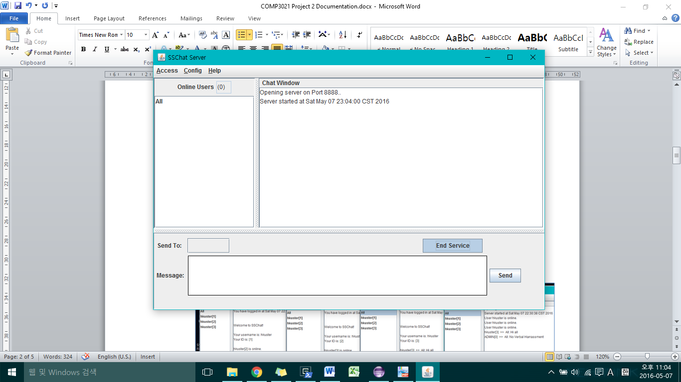

* **System Level Message**: The Server-Side can send Admin messages to an individual user or everyone who is online. This will send the message to the respective Client Thread listening to the Server.

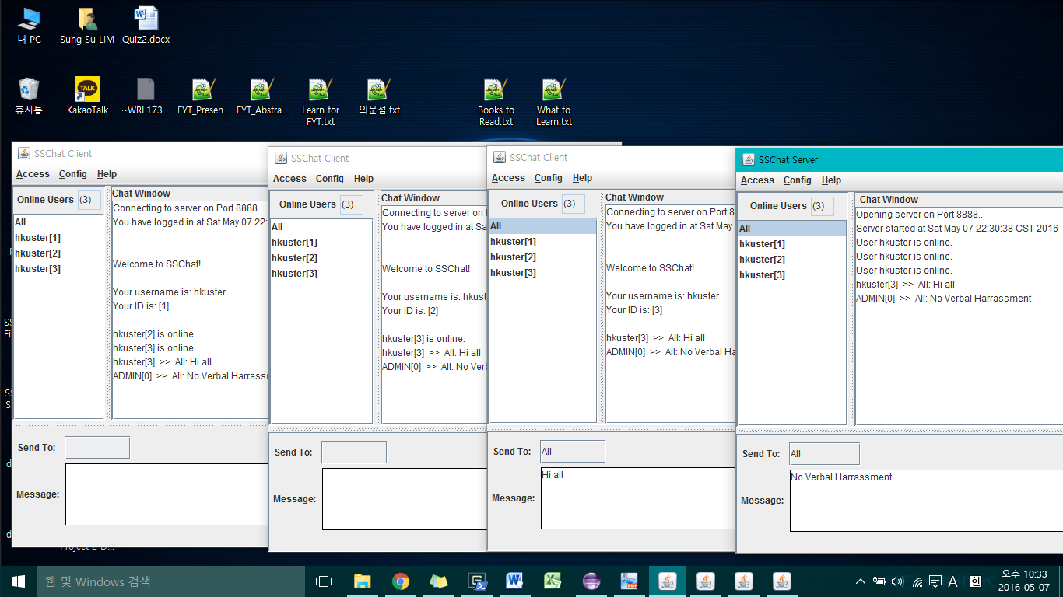

* **Exit**: Exits program and shuts down the Server-Side.

**Client-Side:**

* **User Configuration**: Sets the user name used for chatting. The default name is “hkuster.” The user can either choose to change it before connection or after connection. When changing during connection, the Client first notifies the Server that a change will occur. The Server then updates the username in its current online User List. The Server notifies that a user name change has occurred to all online Clients. For other clients, they update their online User List. For the client who requested for username change will get validation and will also update its username and online User List.

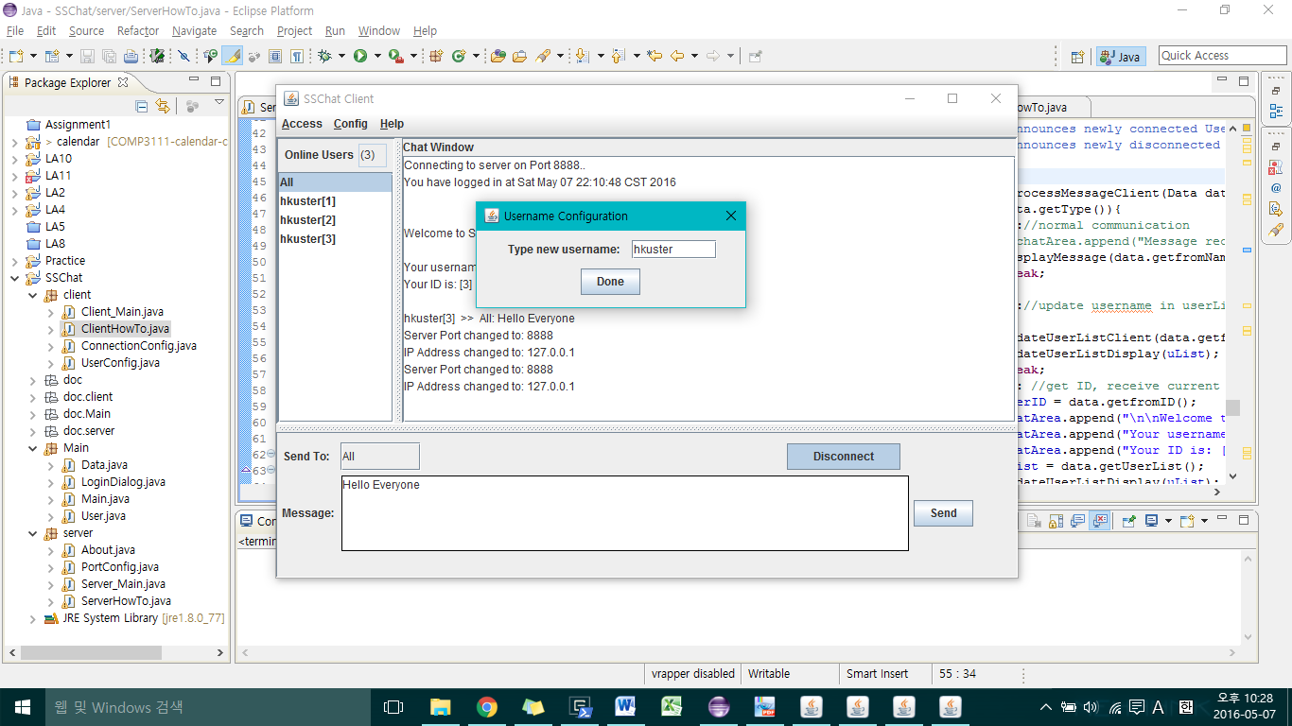

* **Connection Configuration**: Sets the IP Address and port of the Server-Side to connect. This should be done before connecting to the server.

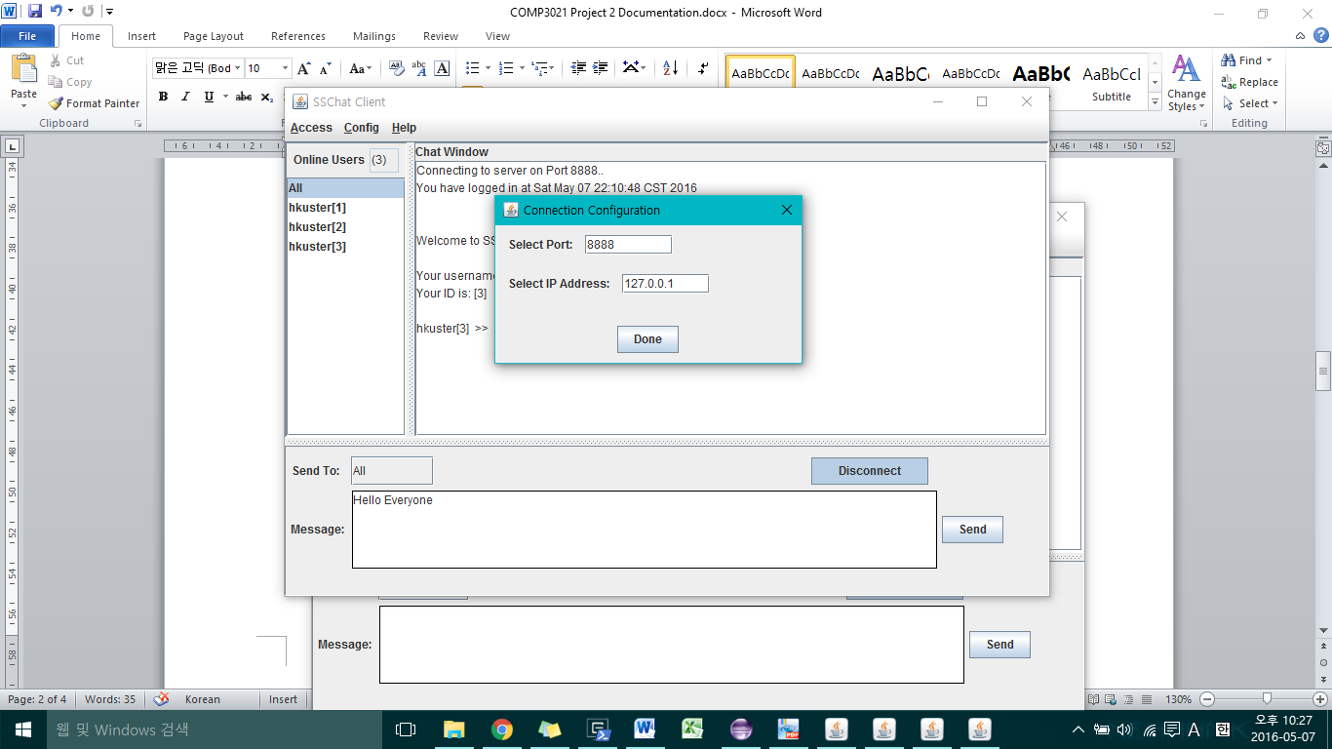

* **Connect/Disconnect (Log-in/Log-off):** Connect/Disconnect to the Server (chatting room). When the user connects to the chatting room, the Client creates a connection with the specified IP Address and Port Number. After a connection is established, the Client creates a new Thread to listen to any Data input from the Server. Initially, the Client sends the username information to the Server. The Server then assigns a unique ID to that Client and then updates the current online User List. The Server sends back the unique ID and the current online User List to that Client, and notifies all other online users that a new Client has connected. Similarly for Disconnect, when the Client disconnects, it notifies the Server. The Server then closes that connection and notifies other online Clients that a particular Client has disconnected.

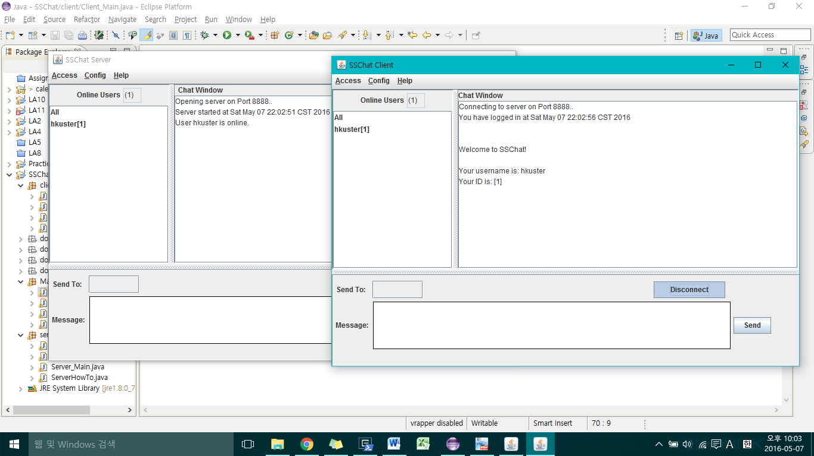

* **Send Messages**: The user can send messages to an individual user or everyone who is online. The User can select whom to send to by selecting the User List Box on the left. Send To Textfield will be immediately filled in, and after inputting the text, the user can send the message. The message is first sent to the Server, where the Server sends the message to appropriate Client(s).
  + **1 to 1 Communication**

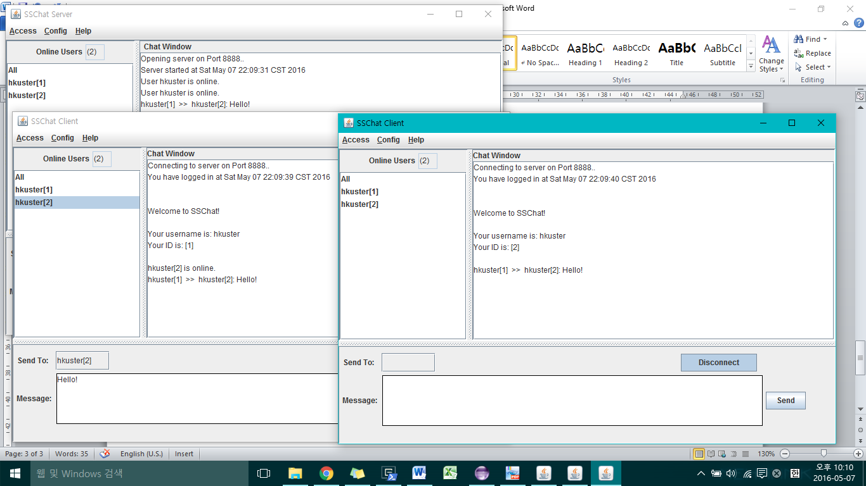

* + **1 to All Communication**

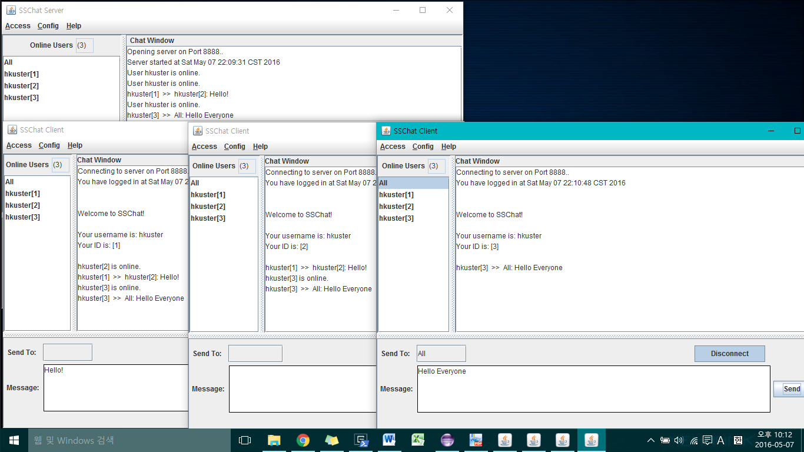

* **Exit:** Shuts down Client-Side

**Help Functionality**

Apart from the important functionalities, there are other help functionalities that tells/shows the users how to use the system.

* **How to**
  + **Server-Side**

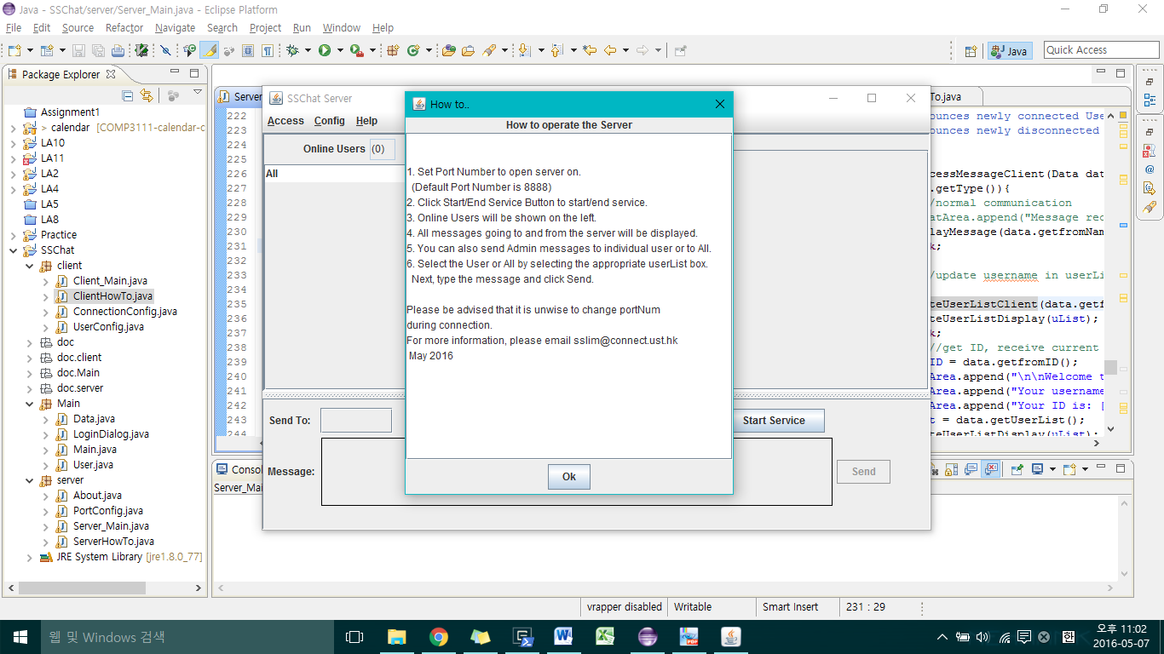

* + **Client-Side**

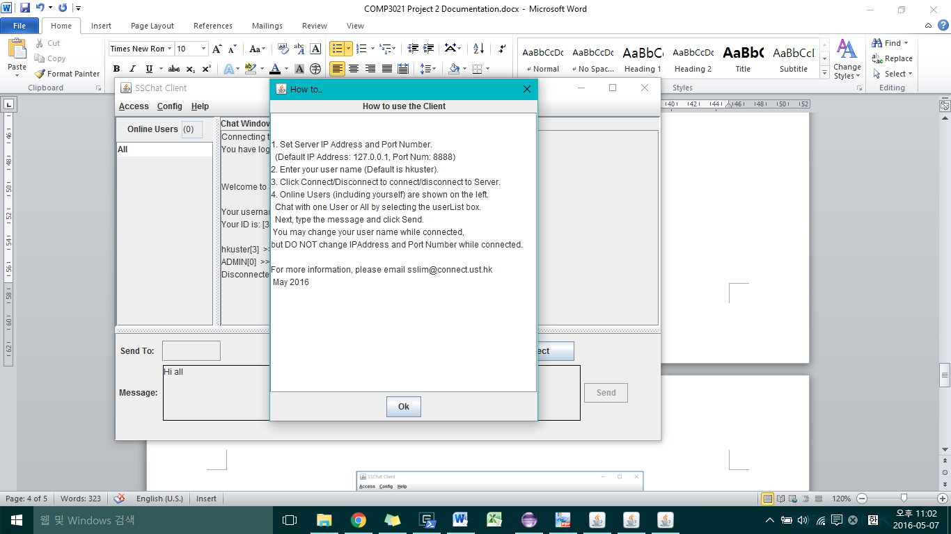

* **About**

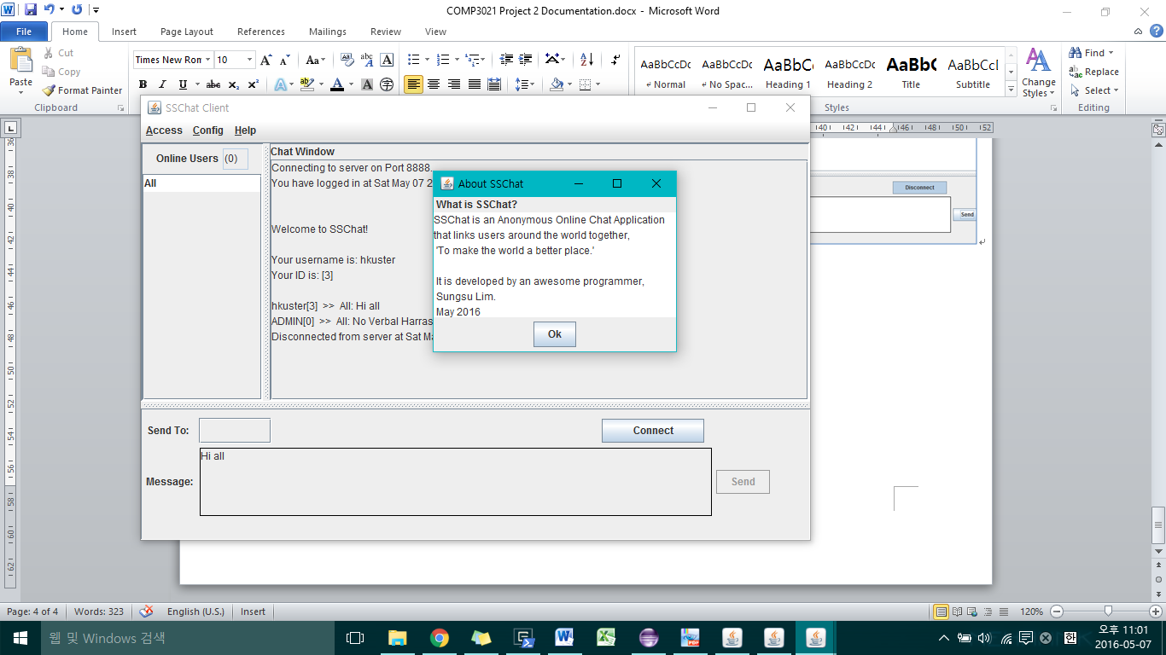

**Thank you!**